**Assignment 5.3**



Ques 1:



Ques 2:

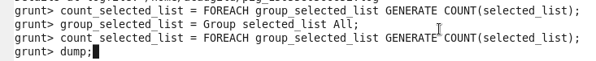

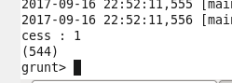

Ques 3:



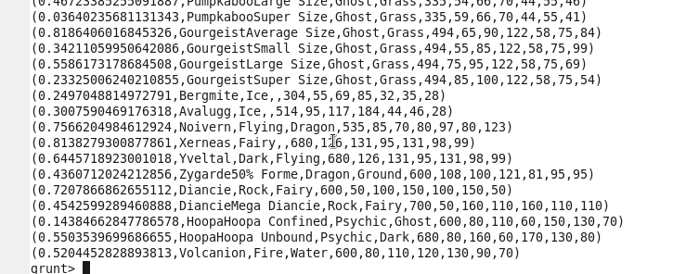

Ques 4:



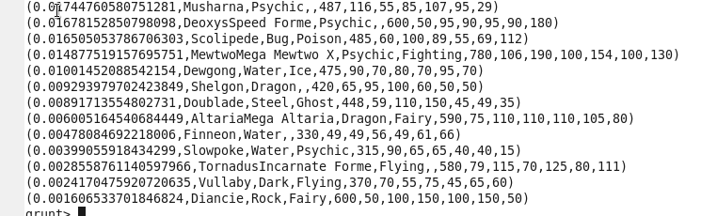

Ques 5:



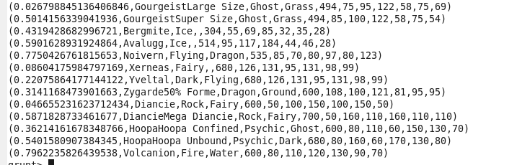

Ques 6:



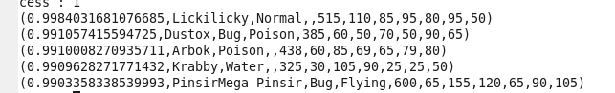

Ques 7:



